Adjustable Main Jet Kit for TM24-9
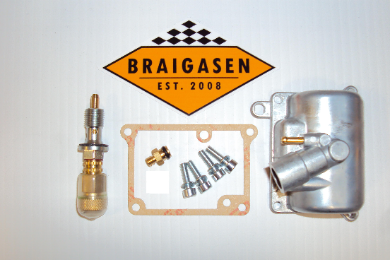
A carburetor equipped with this kit makes it easy to find the right size of main jet
Important
The adjustable main jet is just a tool that facilitates the changing of main jets - thus it has no influence on throttle openings below ¾. Since the adjustable main jet only works above this range you must still have to find the correct pilot jet, needle and needle jet as per usual.
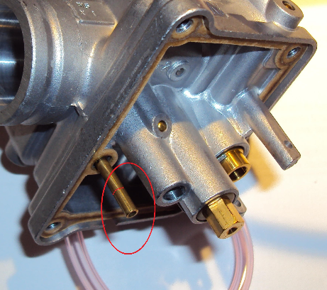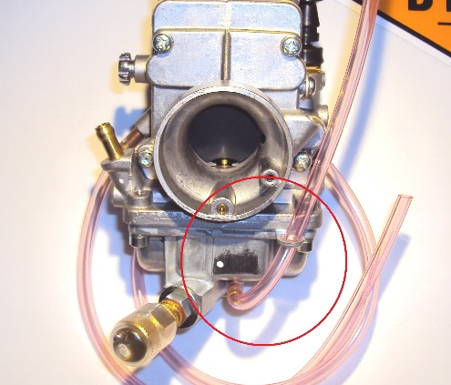
The small brass tube must be The "drain hose" must pass through the shortened loop of the floatbowl pointing upwards
Procedure
1) Shorten the brass fuel enricher tube 6mm (left picture). 2) Remove the main jet but keep the brass washer in place. 3) Install the o-ring adapter and gently thighten it with a 8mm wrench.
4) Install the float bowl after having placed some grease on the o-ring.
After having installed the TM24-9, set the adjuster screw two turns out from fully seated. This corresponds roughly to a #350 jet (4/042 ) which will be too rich for your motor. With a fully warmed up bike go for a ride. You will notice that it does not respond very well. Stop and adjust the setting screw clockwise and go for another ride. Repeat the procedure until you find the spot where it begins to respond and run smoothly on WOT. After this, open the set screw in order to find the spot where it is just on the verge of being too rich. This is the spot you should aim for.
Do not remove the transparent rubber cap! It prevents the adjustable main jet from unsetting and it is still adjustable with the cap in situ.
Approximate corresponding settings for the adjustable main jet
- 1/4 = #60  - 1/2 = #110  - 3/4 = #140  - 1 = #170 | - 1 1/4 = #210  - 1 1/2 = #250  - 1 3/4 = #300  - 2 = #350

